**Junit Result**

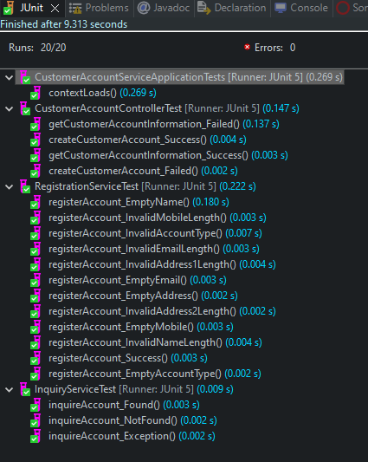

**Code Coverage**

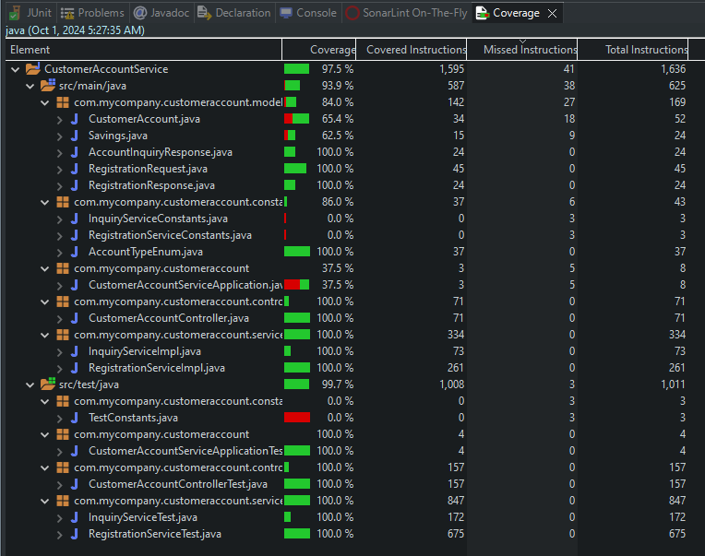

**Postman Test Result**

**HTTP Method**: POST

**Endpoint URL**: <http://localhost:8080/api/v1/account>

Test 1 – Valid payload

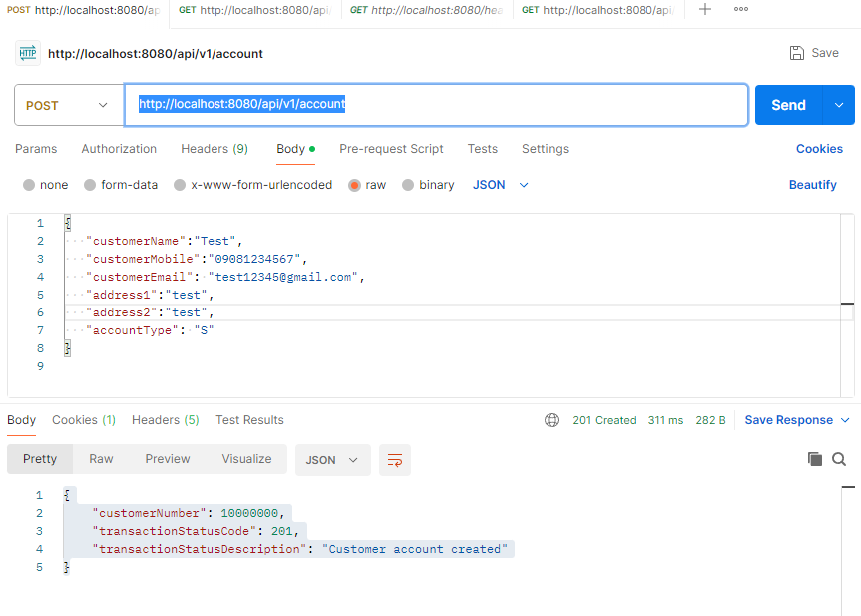

Test 2 – Valid payload

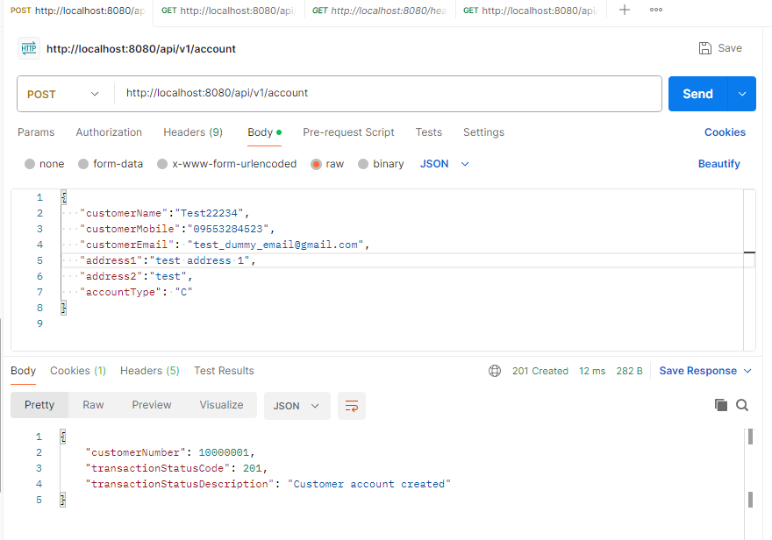

H2 Database Entry:

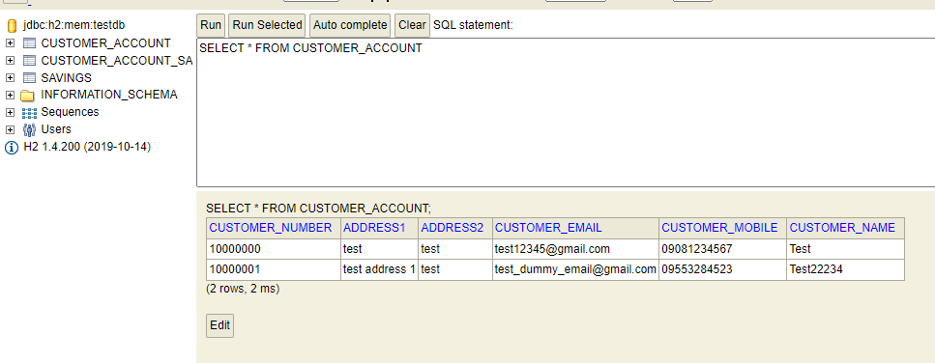

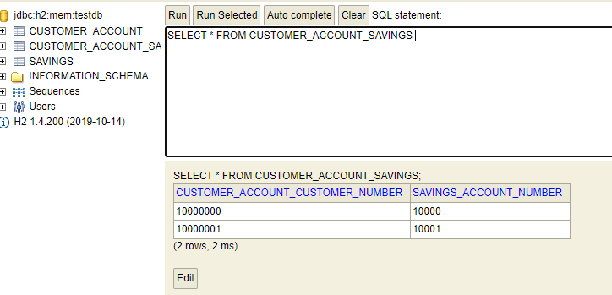 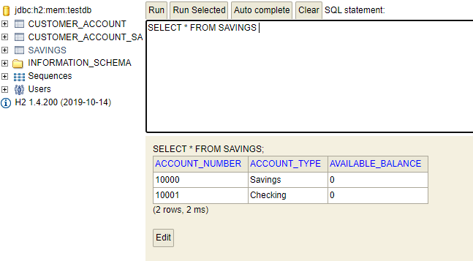

Test 1 – Invalid payload

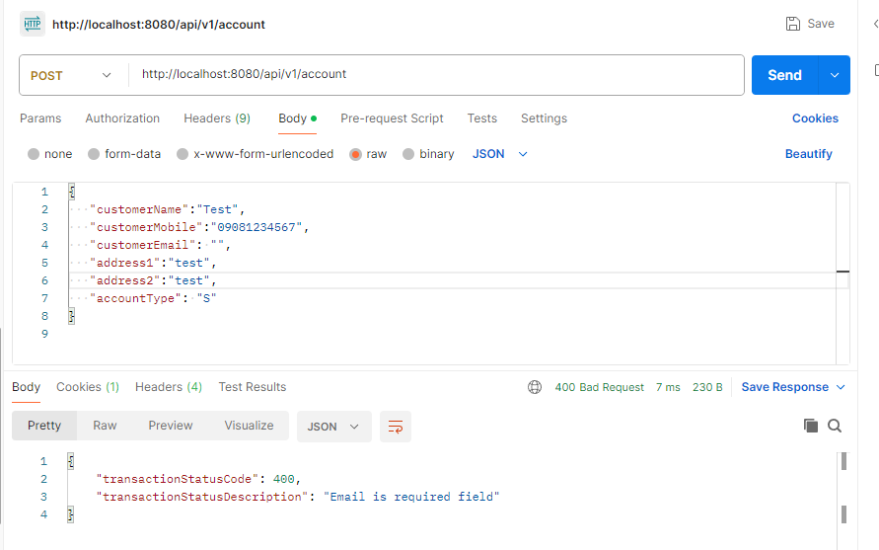

Test 2 – Invalid payload

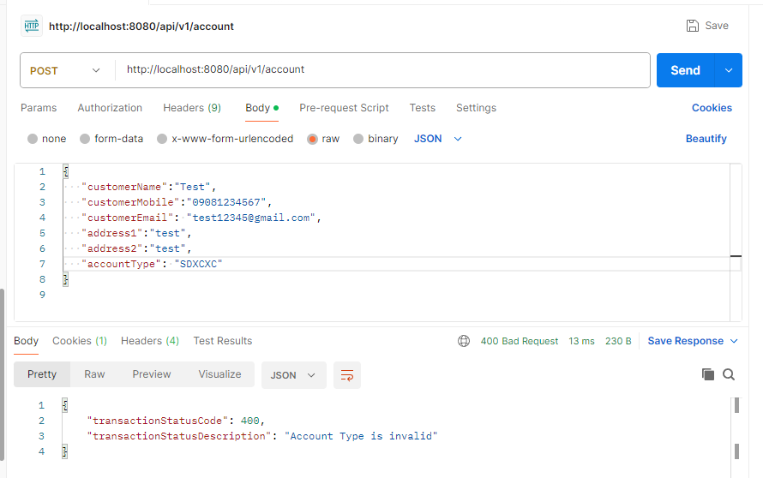

**HTTP Method**: **GET**

**Endpoint URL**: [http://localhost:8080/api/v1/account/{customerNumber}](http://localhost:8080/api/v1/account/%7bcustomerNumber%7d)

Test 1 – Valid parameter

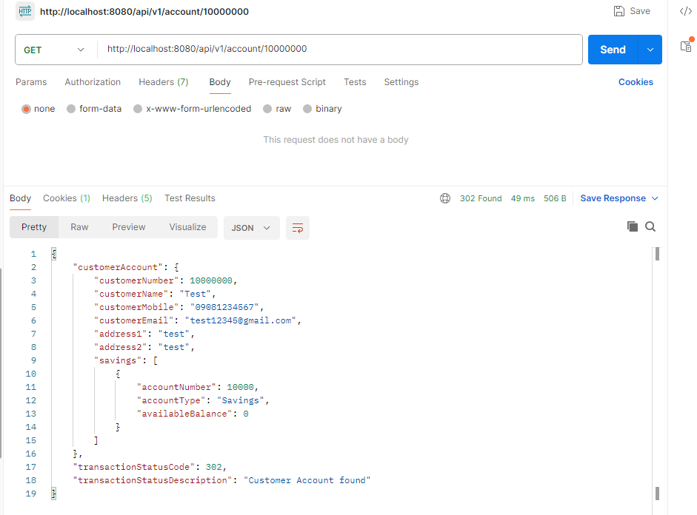

Test 2 – Valid parameter

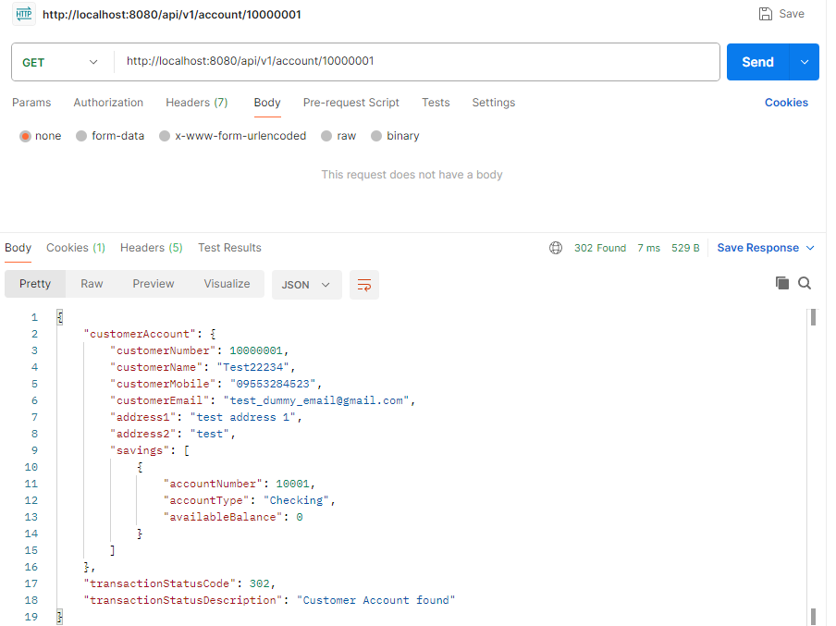

Test 1 – Invalid parameter

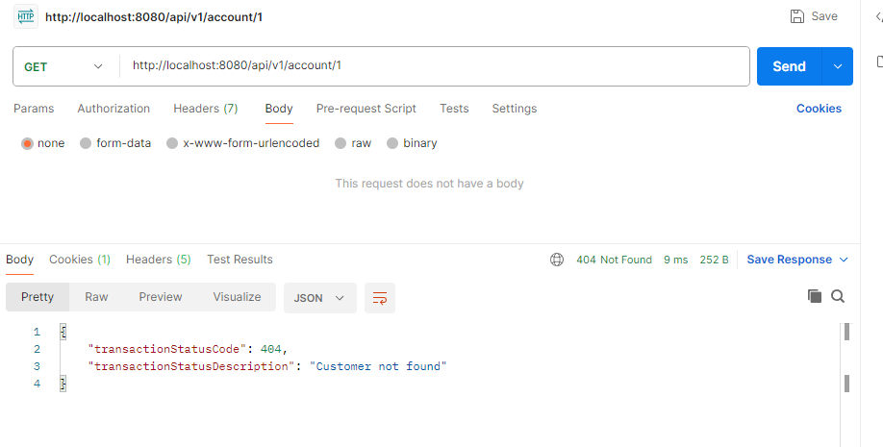

Test 2 – Invalid parameter

